Lab Task 2

Name : M.Shafeen

Roll No : 22P-9278

Step : 1
First we RUN the “afd c01-01.com” command to run the file named c01-01 in the DEBUGGER

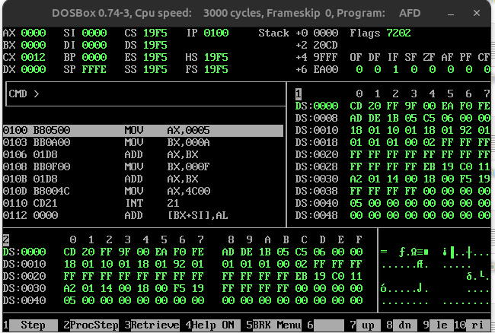
Explanation Of the DEBUGGER:

M1 :
It displays the MEMORY of the CODE in our computer ( DATA )
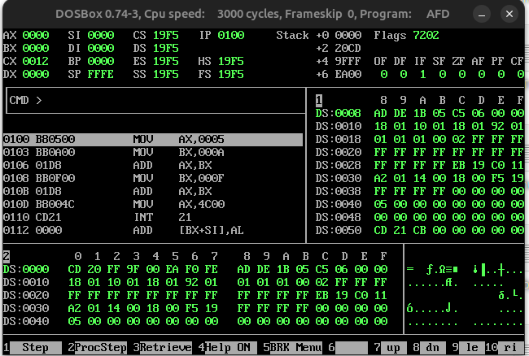
As you can see in the DS:0008 moved from address DS:0000

M2 :
M2 represents the memory of our CODE as a WHOLE ( CODE )
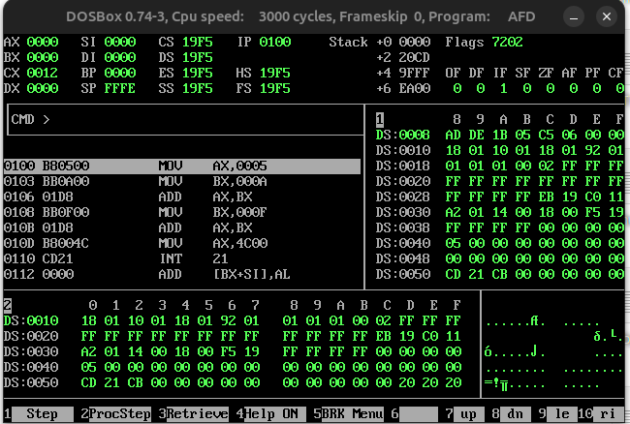

Registers :
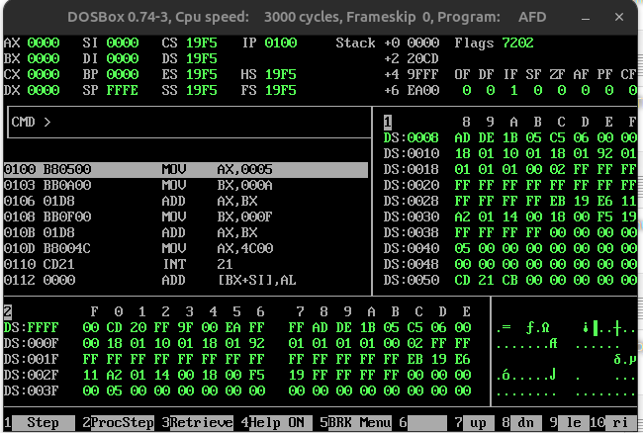

Code Section / Instruction Section / Instructions in MEMORY :
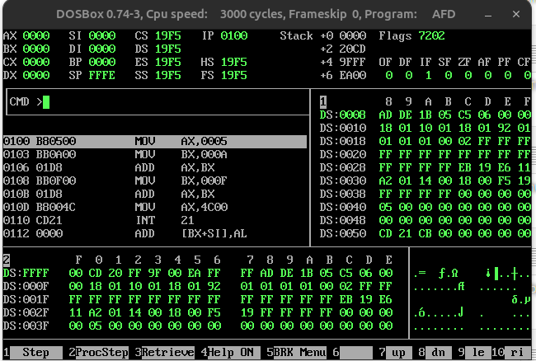

Norse Methodology Symbols :

Instruction Pointer ( IP ) :
The instruction pointer tells us what commands are to be run next from MEMORY...

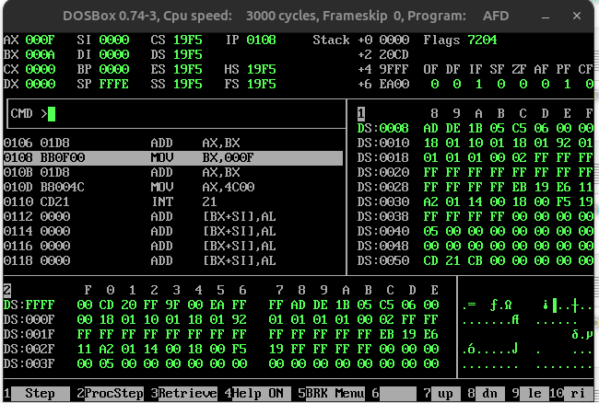
Step : 2
As you can see below after pressing F1 on the UBUNTU LINUX ( QWERTY KEYBOARD ) , The instruction of MEMORY ADDRESS ( 0100 ) runs and moves the value 5 into AX ( ACCUMULATOR REGISTER )…..
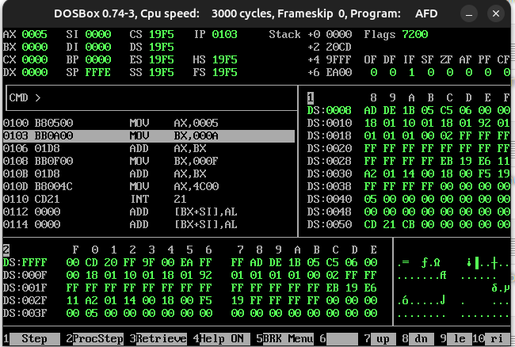

Step : 3
As you can see below after pressing F1 on the UBUNTU LINUX ( QWERTY KEYBOARD ) , The instruction of MEMORY ADDRESS ( 0103 ) runs and moves the value 10 into BX ( BASE REGISTER )…..

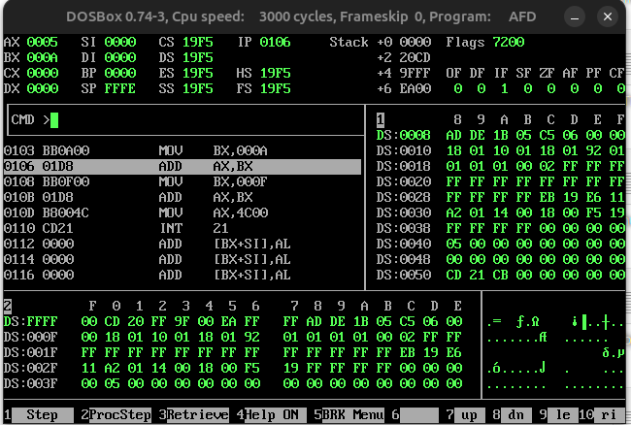

Step : 4
As you can see below after pressing F1 on the UBUNTU LINUX ( QWERTY KEYBOARD ) , The instruction of MEMORY ADDRESS ( 0106 ) runs and adds the values of AX ( ACCUMULATOR REGISTER ) AND BX ( BASE REGISTER ) . Stores the result into AX …..
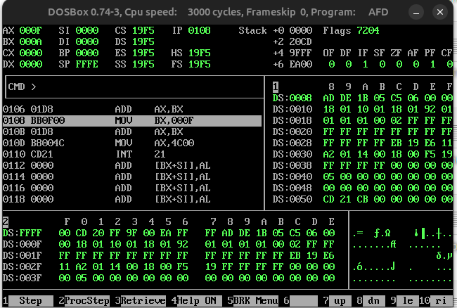

Step : 5
As you can see below after pressing F1 on the UBUNTU LINUX ( QWERTY KEYBOARD ) , The instruction of MEMORY ADDRESS ( 0108 ) runs and moves the value 15 into BX ( BASE REGISTER ) .…..

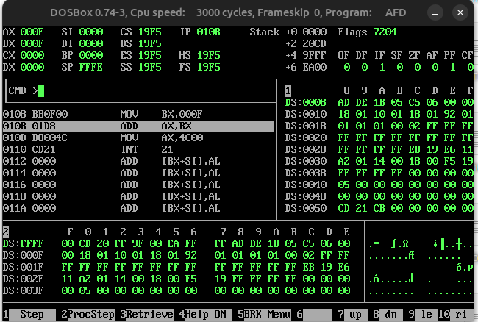

Step : 6
As you can see below after pressing F1 on the UBUNTU LINUX ( QWERTY KEYBOARD ) , The instruction of MEMORY ADDRESS ( 010B ) runs and adds the value of AX ( ACCUMULATOR REGISTER ) AND BX ( BASE REGISTER ).Stores it into AX( ACCUMULATOR REGISTER .…..

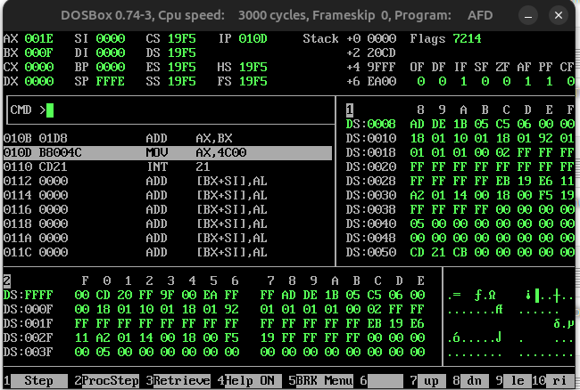

Step : 7
As you can see below after pressing F1 on the UBUNTU LINUX ( QWERTY KEYBOARD ) , The instruction of MEMORY ADDRESS ( 010D ) runs and MOVES the value “4C00” ( which is an interrupt DEFINED by INTEL )...

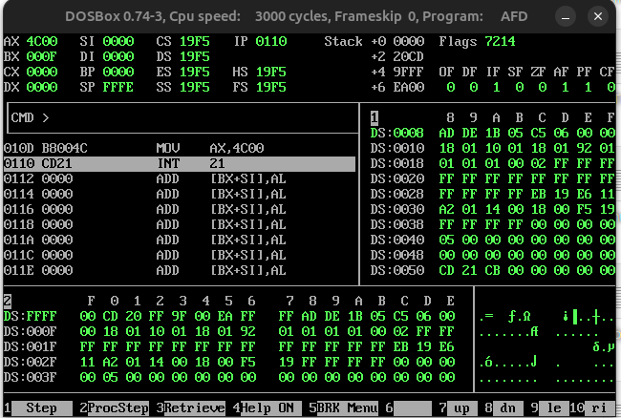

Step : 8
As you can see below after pressing F1 on the UBUNTU LINUX ( QWERTY KEYBOARD ) , The instruction of MEMORY ADDRESS ( 0110 ) runs and CHECKS the most recent value in the AX ( ACCUMULATOR REGISTER ) register in which there is the 4C00 instruction ( which is an interrupt DEFINED by INTEL )...

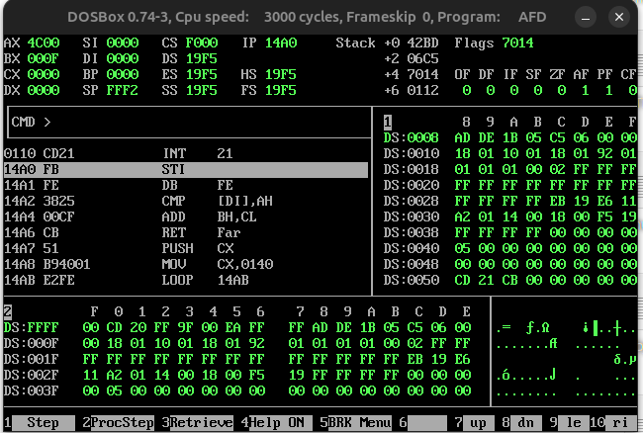

Step : 9
As you can see below after pressing F1 on the UBUNTU LINUX ( QWERTY KEYBOARD ) , The instruction of MEMORY ADDRESS ( 0110 ) runs and program TERMINATES
